Sediment and Substrate: Bedrock-Sediment Interactions Influence River Profiles

**Abstract**

Variation in bedrock erodibility along a river profile gives rise to differences in vertical incision rate and influences sediment characteristics such as clast hardness, coarse sediment generation rate, and grain size. These streamwise sediment dynamics exert critical controls on the erosional mechanisms at work in lowering bedrock elevation and on the expression of transport-limited versus detachment-limited erosional behavior. The role of sediment in shaping a river profile has implications for the steady state fluvial geometry, as well as a river’s transient response to external forcing.

Here we present a model for river profile evolution in a setting with streamwise bedrock variability. We combine theory for five interrelated processes: bedload sediment transport in equilibrium gravel-bed channels, channel width adjustment to flow and sediment characteristics, abrasion of bedrock by mobile sediment, plucking of bedrock, and progressive loss of gravel-sized sediment due to grain-on-grain abrasion. This model contributes to a growing class of “erosion-deposition” models that seek to capture dynamics in mixed bedrock-alluvial rivers, whose behavior fall on a spectrum between fully detachment-limited and fully transport-limited erosional regimes. We demonstrate our model’s ability to reproduce hallmark fluvial features, such as slope-area scaling and knickpoint propagation, and we discuss the role of gravel attrition in influencing the mode of channel behavior, erosional mechanism, channel steepness, and profile concavity.

**Introduction**

Bedrock-incising rivers set the pace of landscape response to changes in geomorphic equilibrium, such as shifts in climate or tectonic regime (e.g. Sklar and Dietrich, 1998, Whipple, 2004, Whipple and Tucker, 1999). These rivers, hereafter referred to simply as "bedrock rivers," cut into bedrock over long timescales, even as their beds are episodically covered with alluvium. It follows that in order to predict large-scale landscape responses to changing climate and tectonics, we require a thorough understanding of the mechanics of bedrock river erosion. In cases where bedrock is episodically covered with a layer of alluvium, we also require an understanding of how this mobile sediment influences the mechanics of bedrock erosion.

The stream power incision model (Howard and Kerby, 1983, Siedl and Dietrich, 1992, Whipple and Tucker, 1999) has achieved widespread use in bedrock river modeling. It is appealing for both its intuitive, physically based nature, and for its ability to reproduce certain characteristic aspects of river profiles, such as transient, upstream-migrating knickpoints and concave-up steady state profiles (Lague, 2014). However, the stream power model also has numerous shortcomings. These include an inability to capture stochastic processes, challenges associated with upscaling short-term discharge measurements into geologically meaningful flow characteristics, and its neglect of sediment abrasion as an important erosional process (Sklar and Dietrich, 2001, 2004, Lague, 2014). Even if one ignores these challenges, the stream power model was developed for bedrock river settings where erosion is “detachment-limited,” meaning the erosion rate is limited by the rate at which material can be detached and mobilized for transport from the riverbed itself (Howard and Kerby, 1983, Howard, 1994b, Whipple and Tucker, 1999), rather than the rate at which mobile alluvium can be transported downstream. The stream power model is not applicable to the latter, “transport-limited” settings, where bed elevation changes are set by the divergence of sediment discharge rather than incision into bedrock (Tucker and Whipple, 2002). This represents a major challenge for the geomorphic modeling community: how should we approach modeling of large-scale river systems, which transition from bedrock beds in their headwaters to alluvial beds downstream, where a single erosion law will not apply?

Even in tectonically active, montane catchments, where the stream power model may be deemed most appropriate, recent work suggests that sediment transport is an important process that sets slopes and consumes a significant portion of the energy budget of “bedrock” rivers (Pfeiffer et al., 2017, Lai et al., 2021). Gravel-bed rivers, which are common around the world in montane settings, exhibit behavior characteristic of transport-limited, alluvial, “equilibrium channels” (Parker, 1978) – their widths are self-adjusted to transport a median grain size (Wickert and Schildgen, 2019, Phillips and Jerolmack, 2016).

Additional work has shown that rivers that may be described as "bedrock rivers" can exhibit transport-limited behavior with dynamics best captured by transport-limited models (Johnson et al., 2009); this may be especially true when the "bedrock" in question is actually poorly consolidated Holocene sediments (e.g., Hobley et al., 2011.) In addition to setting slopes and controlling channel width, sediment also plays a key role in controlling channel incision. Work by Sklar and Dietrich (2001) demonstrated that saltating bedload sediment is capable of incising bedrock via abrasion, a process that involves bed material being dislodged as a result of particle impacts. The authors recognized that the effect is non-linear: at low sediment supply rates, the sediment mainly acts as abrasive “tools” that promote erosion of the bed; as supply increases, increasing “cover” on the bed inhibits further erosion. This work led to the development of mechanistic models that focus on erosion accomplished via sediment abrasion rather than through a stream power formulation (Sklar and Dietrich, 2004, Chatanantevet and Parker, 2009.)

These challenges and complexities summarize the need for models that explicitly account for sediment effects, both in terms of how sediment influences the erosional process (namely, the relative importance of abrasion) and how sediment supply controls (both spatially and temporally) the general erosional style: transport-limited versus detachment-limited. Efforts have been made to address both of these issues via the development of “erosion-deposition” models that are capable of capturing both the removal of material from the bed and the re-deposition of that material at some point downstream. If the distance at which re-deposition occurs is sufficiently short, then the model is effectively “transport-limited,” while if the distance is long the model is “detachment-limited.” These models are capable of capturing intermediate erosional behaviors, and some can explicitly capture dynamics such as the thinning and thickening of alluvial bed cover (Davy and Lague, 2009, Shobe et al., 2017). However, the models developed by both Davy and Lague (2009) and Shobe et al. (2017) are best-suited to suspended load sediment. As a community, we are still lacking a model that transitions from detachment- to transport-limited behavior for explicitly coarse sediment.

While transport-limited and detachment-limited erosional models can produce the same steady state river profiles, the choice of erosion law does result in markedly different transient responses to external forces (Tucker and Hancock, 2010). The study of transient river responses to climate or tectonic perturbations can therefore be very useful in determining the correct fluvial erosion law to apply to a given river system.

Recent advances in erosion-deposition models have provided nuance to our understanding of rivers that exhibit traits of both detachment- and transport-limited behavior, and these models seem promising in terms of their ability to improve our understanding of fluvial response to external forcing. However, these models often assume uniform lithology and sediment supply. Meanwhile, questions surrounding how rivers adjust to heterogeneous lithology and evolving sediment supply are active areas of research in their own right. Work by Gabet (2020a) found that in the Sierra Nevada (a highly heterogenous terrain), rivers adjust their profiles to accommodate differences in both the erodibility of the bedrock itself and in the lithologically controlled median grain size. Gabet (2020b) then showed that rivers with heterogenous lithology will generate different transient knickpoint behavior in response to two types of tectonic perturbation: uniform uplift and tilting. Work by Lai et al. (2021) in eastern Taiwan also demonstrated differences in channel steepness attributed to upstream controls on sediment supply where rivers cross a lithologic contact.

Figure 1. The juxtaposition of crystalline and sedimentary rocks is common around the world in mountain foreland basins. Large, subcontinental scale rivers that drain the ranges encounter changes in rock type, and therefore erosional process, from their headwaters to their downstream reaches.

Other studies have focused more explicitly on how sediment load changes across lithologic boundaries; in these studies, the boundaries represent major shifts in physiographic province, such as crossing from a range composed of crystalline rocks into an adjacent sedimentary basin. Studies conducted in both the Himalaya (Dingle et al., 2017) and the Colorado Front Range (Menting et al., 2015) have demonstrated that crossing such a contact typically does not result in representation of downstream units in the sediment load. Rather, the sediment load continues to be dominated by sediment derived from the most resistant units found along profile. These units become enriched in the sediment load downstream, even as they represent a smaller and smaller fraction of the total drainage basin. In the Himalaya, all but the most resistant clasts experience rapid downstream fining which is attributed to sediment abrasion (Dingle et al., 2017). In the Colorado Front Range, downstream fining occurs on a spatial scale shorter than that predicted in abrasion mill experiments, which points to a selective transport control on streamwise grain size in addition to sediment abrasion (Menting et al., 2015).

This study draws from the areas of research outlined above, particularly our increasing awareness that gravel-bedded rivers can behave as alluvial rivers over short timescales, while also incising bedrock over long timescales, and may adjust their widths dynamically with changing bed and sediment conditions. We are inspired by a case study in the Southern Rocky Mountains, where rivers traversing the crystalline Front Range exit into the sedimentary basin of the High Plains. In this setting we observe the sediment load being dominated by granitic clasts sourced from the mountains (Menting et al., 2015). We investigate what impact this coarse, erosion-resistant bedload has on the downstream profile of rivers that flow over sedimentary rocks. We implement an erosional scheme based on sediment cover that allows for both abrasion and stream-power erosion, and that honors the gradual transition from detachment-limited behavior in the mountains to transport-limited behavior on the plains. In this way, we can make predictions about river profiles produced when this lithologically heterogeneous landscape responds to changes in climate and tectonics. We pay special attention to how these changes may at times be compensated for through erosion of bedrock, and at other times through changes in the thickness of an alluvial mantle.

All of this points to a need to move away from models that rely on empirical width-discharge relationships

**Methods**

Here we present a numerical model that attempts to fill gaps in our current modeling capabilities. We envisage a river that traverses two distinct physiographic provinces: an upstream reach comprising erosion-resistant crystalline rocks, and a downstream reach composed of highly erodible, fine-grained sedimentary units. In both domains, total topography is the sum of bedrock elevation plus some thickness of alluvial sediment that mantles the riverbed. We borrow from Wickert and Schildgen (2019) and conserve mass within a valley of fixed width, while allowing channel width to vary.

In brief, our model erodes sediment from the valley bottom and surrounding hillslopes, carries a fraction of that eroded material as bedload in the channel, and loses some fraction of bedload mass downstream to grain attrition. We assume that erosion occurs only through plucking and abrasion, as these are thought to be the dominant erosional processes in bedrock rivers (Whipple, 2004). The efficiency of bedrock erosional processes is modulated by the fraction of bedrock exposed and the sediment flux, honoring the observation that bedrock erosion rates initially increase under conditions of increasing sediment supply due to the presence of “tools” that promote erosion via abrasion; above a critical threshold, however, increasing sediment supply inhibits erosion by covering the bed and shielding it from abrasive impacts (Sklar and Dietrich, 1998, 2004). Finally, rather than assuming downstream increases in sediment load scale only with slope and discharge (Smith and Bretherton, 1972), we will honor the observation that coarse sediment decreases in size downstream due to particle attrition (Sklar and Dietrich, 2001, Attal and Lave, 2006, Menting et al., 2015). The attention paid in our model to both bedrock and sediment properties leads to a unique feature of our model: the relative importance of different erosional mechanisms (plucking and abrasion) varies depending on the properties of both the substrate and bedload material.

Our model does not account for the differences in shear stress associated with different styles of plucking detachment, per Gabet 2020b. Instead, all plucking is accomplished through a simple stream power formulation (see below). We also do not account for large (boulder-sized) clasts in the system. We use a single discharge-area relationship, rather than a stochastic formulation. And finally, when calculating erosion via abrasion, we use generic abrasion coefficients that have been found for different rock types (Attal and Lave, 2006) in order to be broadly representative of "highly erodible" and "erosion-resistant" geologic units; our study is not intended to be grounded in a specific field site, and therefore we have not conducted fieldwork to measure fracture density or other field-based observations that would inform a more realistic formulation of abrasion coefficients.

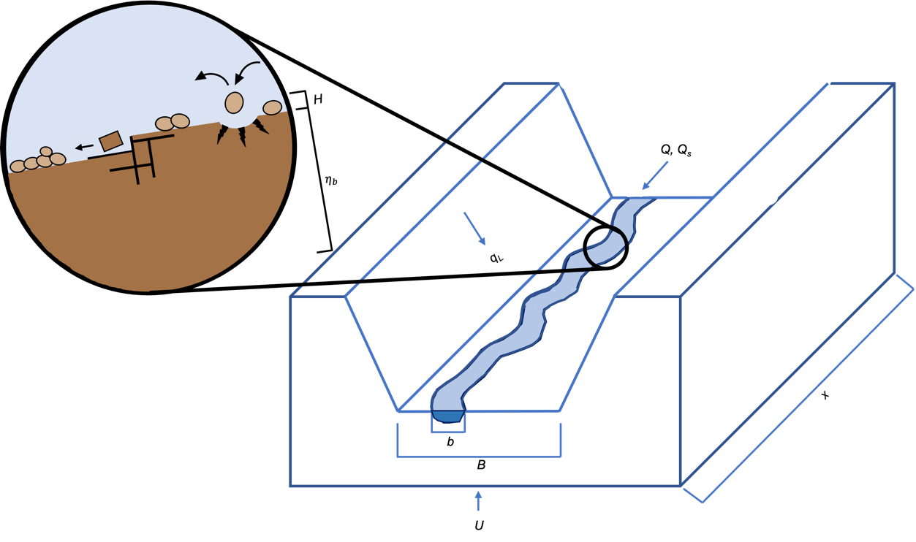

Figure 2. Schematic illustration of sediment transport and erosion in our model. Sediment enters the channel/valley from upstream and from hillslopes/tributaries, which are assumed to be lowering at the same rate as the channel. Bedrock erosion within the channel occurs via both abrasion and plucking, but only where bedrock is exposed (not covered with alluvium).

In the sections below we first outline the governing equations of our model, and then describe our methodology for testing the model.

**Governing Equations**

The fundamental equation in our model that determines how river profiles evolve through time states that the rate of change of total elevation is equal to the rate of change of bedrock elevation, plus the rate of change of some thickness of sediment that sits atop the bedrock profile:

where is the total topographic elevation [L], is the bedrock elevation [L], and is the sediment thickness [L]. Each term on the righthand side can be broken down into its contributing pieces: bedrock elevation is controlled by uplift and bedrock erosion, and sediment thickness depends on the amount of coarse material present, lateral contributions from the surrounding basin, the sediment flux, and the amount of mass lost from the bedload due to grain attrition. The general forms of these equations are as follows:

Erosion and sedimentation rates in our model depend upon an interaction between bed cover, sediment flux, bedrock erodibility, and sediment hardness. These interactions are outlined in equations below.

**Fixed Width Valley, Varying Width Channel**

Mass is conserved within a valley of fixed width, while a channel with varying hydraulic radius exerts control on local sediment transport and erosion rates. Equations for valley and channel width are taken from Wickert and Schildgen (2019), and are calculated as follows:

Where *B* is valley width [L] and *b* is channel width [L]. *kB* and *kb* have values of 25 and 8.3 x 10-8, respectively. *Q* is the total discharge with dimensions [L3/T], and is calculated as follows:

Where *r* is a runoff rate ([L/T]), *kh* is a Hack coefficient related to basin geometry, and *h* is a Hack exponent, also related to basin geometry. See Wickert and Schildgen (2019) for full derivations of *B* and *b.*

**Bed Exposure**

We use an exponential function, formulated after Shobe et al. (2017), to calculate , the effective bed exposure:

Here H represents the actual sediment thickness present on the riverbed, and H* is a characteristic scale that approximates bed roughness height. When the actual sediment thickness, H, is large relative to the roughness height H*, bed exposure is minimized; when actual sediment is thin relative to the roughness scale, bed exposure is maximized. FIGURE?

**Sediment Flux**

Our model uses a shear-stress dependent formulation for bedload transport derived by Wickert and Schildgen (2019). Their derivation results in a formulation in which sediment flux is dependent on slope, discharge, and flow intermittency; we modify their expression by adding in our bed cover term:

where kQs is a lumped, dimensionless coefficient whose value assumes a constant shear stress slightly above that needed to transport the median grain size at bankfull conditions (Parker, 1978), I is an intermittency factor that describes how often geomorphically effective flows occur within the channel, q is the water discharge per unit channel width, S is the channel slope, and the term (1 – ) describes the fraction of the riverbed covered by sediment. When (bed exposure) is sufficiently small, the bed is effectively 100% covered by mobile sediment and sediment flux, qs, will be maximized.

**Bedrock Erosion**

We allow for erosion to occur through two mechanisms: plucking and abrasion. The effectiveness of each of these mechanisms depends on the percentage of bedrock exposure on the riverbed. Dubinski and Wohl (2012) found a linear relationship between stream power and plucking rate in bedrock; we therefore use a version of the stream power model (Whipple and Tucker, 1999), modified to include our bedrock exposure term, to calculate the rate of erosion via plucking:

where K is the bedrock erodibility and is the fraction of bedrock exposed.

Abrasion is accomplished through sediment impacts on the riverbed. We borrow our abrasion formulation from Chatanantavet and Parker (2009), where the amount of material removed for each sediment impact depends on the abrasion coefficient of the bedrock substrate, , and the sediment flux. As before, we modify these authors' equation to include the percentage of bedrock exposed:

While both Ep and Ea include factors related to rock strength, the erodibility factor used in Equation (4) depends more on large-scale features of the bedrock such as jointing, while the abrasion coefficient used in Equation (5) is related to strength at the grain scale. Erosion via abrasion is expected to dominate in rocks that are weak at the grain scale (Whipple, 2004). Since our model traverses multiple lithologies (multiple K values), both equations (7) and (8) will have as many forms as there are lithologies represented in the model (in our case, two). These forms may be denoted, for example, Ep, ig and Ep, sed to differentiate plucking of igneous and sedimentary lithologies.

**Lateral Sediment**

Sediment enters the valley through lateral inputs that represent combined hillslope and tributary erosion. To calculate this sediment input, we assume that the surrounding hillslopes and tributaries are lowering at the same rate as the local mainstem channel incision. As in the main channel, any sediment moving through the tributary system will be subject to attrition; therefore, the lateral sediment flux to the valley at any point will be a function of the distance traveled, which itself is assumed to depend on drainage basin geometry. This relationship is expressed as such:

Here, is a parameter that represents what fraction of hillslope material enters the tributaries as coarse gravel.

**Attrition**

In addition to sediment abrading the riverbed, gravel clasts in transport in a real system will also abrade one another, which is one of the principal mechanisms at play in downstream fining. We refer to this grain-on-grain action as "attrition" in order to differentiate it from "abrasion," which will refer solely to vertical lowering pf the profile resulting from grain impacts on the riverbed. The rate of grain attrition, , is a function of the abrasion coefficient of the sediment comprising the bedload and the amount of sediment in transport, i.e. the sediment flux:

**Sedimentation**

Sedimentation in our model is the sum of processes that contribute to an increase in sediment thickness on the riverbed, and those that degrade bed sediment thickness. Recalling Equation (4), the sedimentation rate depends on the presence of bedload material, lateral sediment inputs, the sediment flux, and grain attrition. As math, this is written:

When calculating the sedimentation rate, only coarse material plucked from highly erosion-resistant lithologies (i.e., igneous rocks) is considered significant to controlling the amount of bedload material present. Although plucking occurs in softer units, the most erodible clasts in a river system tend to experience rapid downstream attrition and thus they are not persistent in the bedload for long distances (Menting et al., 2015, Dingle et al., 2017).

**Model Implementation**

Our model is implemented on a 1D grid with a total domain length of 100 km and grid spacing of 1 km. A lithologic boundary is imposed at one quarter of the length of the domain (25 km). Between kilometers 0-24, the bedrock is assigned properties (such as erodibility and abrasion coefficient) representative of granitic rocks (Attal and Lave, 2006); from kilometers 25-100, rocks are assigned properties representative of course sandstones and conglomerates (Attal and Lave, 2006). Our model evolves through time in response to "uplift," which we simulate through the progressive baselevel lowering of an outlet node.

The model is designed to capture the changes in dominant erosional process that occur streamwise as sediment builds up and influences the system, much the way real rivers are often detachment-limited in their headwaters and become progressively more transport-limited downstream (CITATION; DAVY AND LAGUE 2009?) In our model, different fluvial conditions can be forced or suppressed with intentional parameter choices. For example, making abrasion coefficients so small that abrasion is negligible, while also making the characteristic sediment thickness (roughness height) so large that it is challenging to completely cover the bed, results in a model that is effectively the stream-power model. Parameter choices in our default model are made based on a combination of empirical data and optimization of runtimes.

**Analytical Solutions**

Analytical solutions are presented for three special cases that represent simplified versions of the model behavior. All cases are solved for a one-dimensional version of the model, meaning we ignore any lateral sediment inputs, and results are presented for a single-lithology terrain. They are presented here in order of increasing complexity. Detailed math for each solution is given in Appendix B.

*Case 1: Unlimited sediment, and no grain attrition*

In this most simplistic demonstration of model behavior, all processes relating to bedrock erosion are ignored, because bedrock is buried beneath an infinitely thick layer of sediment. Uplift occurs on the landscape, but the material being uplifted is an infinite column of sediment, rather than bedrock that requires mechanical conversion to sediment. This analytical solution produces a straight (constant slope) river profile; the numerical solution experiences slight changes in slope along-stream, but these are negligible such that the equilibrium profile is nearly straight.

*Case 2: Unlimited sediment, with grain attrition*

This case demonstrates the importance of grain attrition to producing concavity in alluvial rivers. In this case, sediment is still unlimited, but here mass can be lost from the gravel load via grain-on-grain abrasion (“attrition.”) As in Case 1, uplift is experienced as an uplifting column of sediment, rather than bedrock. This solution produces slopes that decrease downstream, i.e., a concave-upward profile. The degree of concavity is controlled by the abrasion factor used to control the persistence of bedload sediment. More abradable sediment yields a straighter profile, while less abradable sediment yields higher concavity.

*Case 3: Plucking and transport*

This case represents model behavior that honors the dynamics of erosion on a partially alluviated bed, but only considers one erosional process (plucking). This scenario differs from a stream power model, however, because coarse sediment that is generated via plucking contributes to an alluvial layer of varying thickness on the bed, which impacts the efficacy of the plucking process. The case also produces a concave-upward profile, but unlike in Case 2, concavity is controlled via the bedrock erodibility factor, rather than the abrasion factor. Case 3 produces good agreement between analytical and numerical solutions for high to moderate values of K, but the solutions diverge when bedrock erodibility is extremely low, and thus slopes become extremely high. The high slopes of these divergent solutions suggest that, in a real river, little to no sediment would remain on the riverbed, and these would be truly “detachment limited” systems. However, in our model set-up, sediment is allowed to persist on the riverbed for at least one timestep, representing the time between when it is generated from plucking versus when it becomes available for downstream transport, which means that our model is effectively representing sediment inhibition of erosion, which is a process that may be negligible in nature. It is noteworthy that the “missing ingredient” in this special test case, which is present in our full model, is abrasion. As will be demonstrated in Results, high abrasion rates are necessary and sufficient to force our model into fully “stream power” behavior, because this is the means through which we can make sediment effects truly negligible. The behavior presented here suggests that our model cannot account for a sediment-starved system without allowing an abrasion process to eliminate any sediment that might be generated from bedrock.

**Model Testing**

Rivers exhibit certain characteristic forms in both steady and transient cases. At steady state, these forms include a concave-upward profile, as well as power law scaling between slope and area and an increase in channel steepness with uplift rate (Lague, 2014). In transient cases, rivers also exhibit upstream-migrating knickpoints in response to baselevel fall (Lague, 2014). These fluvial behaviors are drawn from both observation and theory [CITATIONS: TAKE FROM LAGUE 2014]. Several field studies have also contributed to our understanding of how rivers behave in lithologically heterogeneous environments: in settings in which a more erosion-resistant lithology occurs upstream and contributes coarse sediment into the system, downstream channel segments are steeper and more concave relative to those in which hard sediment does not occur (Duvall et al., 2004, Johnson et al., 2009, Lai et al., 2021).

In the section below, we review our model’s ability to reproduce these characteristic features. Results are shown for model runs using a single set of default parameter choices [FOUND IN APPENDIX, OR SOMETHING?]. Non-default behavior will be explored in the Discussion section.

**Results**

**Slope-Area Relationship**

Empirical data suggests [CAN SAY A LOT MORE HERE ABOUT THIS] that rivers exhibit power law scaling between slope and area at steady state (Flint, 1974):

where A is area, ks is a steepness index, and is the concavity. This scaling is so common that it is considered a necessary criterion for river incision models to replicate (Lague, 2014). Our model prediction diverges slightly from Flint's Law; however, it falls well within an envelope of uncertainty in concavity measurements from field data in lithologically heterogeneous settings (Duvall et al., 2004).

In profile, this scaling relationship is reflected in concave-upward profiles at steady state. Our model consistently creates concave upward river profiles at the steady state condition when erosion rate is equal to uplift rate. These profiles exhibit a break in slope associated with an imposed bedrock contact, and steepness, particularly in the downstream reaches, can be modulated with the persistence of large sediment (i.e., the abradability of the sediment). However, the general shape is consistent.

**Steepness-Uplift Relationship**

Channels are expected to become increasingly steep as uplift rates increase (Lague, 2014). Channel steepness can be examined by calculating a normalized steepness index, *ksn,* or by simply examining a slope-area plot [NEED FIGURE MODIFIED FROM DUVALL 2004?]. We find that our model uniformly predicts this behavior.

**Transient Knickpoints**

Figure 3. General model behavior. In all panels, an imposed bedrock contact is shown with a vertical dashed line. (A) Steady state profiles have a break in slope at an imposed bedrock contact. (B) Slope-area relationships fall within field data for uncertainty in concavity measurements. (C) Steepness increases with uplift rate. (D) Knickpoints resulting from a baselevel fall propagate upstream. (E) The presence of harder sediment leads to steep profiles.

Rivers tend to exhibit upstream-migrating knickpoints in response to relative baselevel fall. Our model does that. Due to the presence of multiple bedrock lithologies in our model, the speed of knickpoint propagation cannot be modeled with a single equation, as in Lague (2014). Nonetheless, we can observe the knickpoint slowing as it moves through the more resistant unit by examining progressive time stamps as the perturbed profile relaxes back to an equilibrium state. This behavior – a knickpoint moving rapidly through more erodible material and slowly through less erodible rock – aligns with incision as predicted by the stream power model (Eqn 1). NEED FIGURE SHOWING THIS BEHAVIOR ON MULT GRID SIZES? OR SOME WAY AROUND GRID DIFFUSION ISSUE.

**Effects of Hard Sediment in the Channel**

Field studies have demonstrated that rivers carrying coarse sediment that is hard relative to the riverbed substrate tend to have 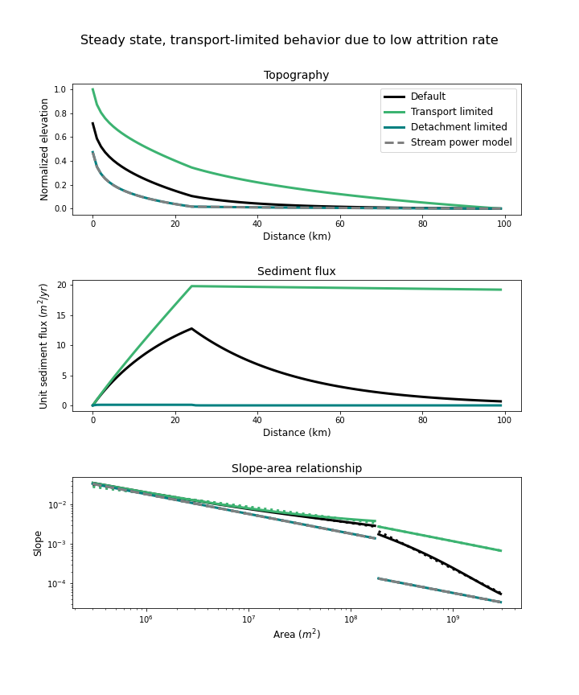steeper downstream profiles (Duvall et al., 2004, Johnson et al., 2009, Lai et al., 2021). This may be due to sediment armoring the riverbed, leading to the preservation of an increased transport slope. Our model is consistent with these results.

**Discussion**

**Effect of Changing Attrition Factor on Steady Profiles**

The abrasion factor has emerged as the most important parameter capable of shifting fluvial behavior from transport-limited to detachment-limited styles of erosion. When the abrasion factor is sufficiently low, grain attrition is negligible, which causes any gravel generated through plucking to be extremely persistent in the sediment load. This allows for the sediment layer to increase in thickness, thus decreasing the prevalence of bedrock erosion and increasing the sediment transport rate. Fully transport-limited behavior would be indicated by a plateauing of the sediment transport rate along stream; we approach this behavior when is sufficiently small.

Figure 4. Results of altering the abradability of sediment, i.e, the attrition factor. When this factor is small, the model exhibits transport limited behavior, leading to (A) increased transport slopes, especially in the downstream reaches, (B) a plateauing sediment flux, and (c) increased steepness and decreased concavity downstream. When the factor is large, topography is suppressed, sediment flux is negligible, and steepness and concavity are lower.

Conversely, making the abrasion factor extremely large forces the model into detachment-limited behavior, where the sediment transport rate is effectively zero and bedrock erosion, along with uplift rate, exert total control on topography – sediment has no effect. This is effectively the stream power law, which can be seen in Figure 4 from to the complete overlap between this version of our model when compared to predictions from a purely stream power model.

These effects are validated by examining the sediment thickness itself, which confirms that decreasing the attrition factor leads to increases in sediment thickness (Figure 5). Further, we see that low attrition rates lead to gains in the fraction of bedrock erosion that occurs via abrasion; this is because the enhanced persistence of bedload sediment leads to the effect of having more “tools” available to abrade the bed (Sklar and Dietrich, 2004).

**Transient Bedrock Erosion Dynamics?**

**Conclusions**

These results demonstrate the viability of our model to reproduce realistic fluvial features, while also reinforcing the importance of honoring sediment-bedrock interactions in determining fluvial process and, ultimately, fluvial form over long timescales and in lithologically heterogeneous environments. Our model has broad applications to settings that include sedimentary basins adjacent to mountain ranges, and large fault systems that bring different rock types in contact over regional scales.

**References**

FIGURE SHOWING ENDMEMBER BEHAVIORS REACHED WITH TWEAKING H*?

Cloud of behaviors generated by tweaking all params?

**Appendix A: Notation**

**Appendix B: Analytical Solutions**

**FIGURE SHOWING HYPOTHETICAL CELL VOLUME**

*Case 1: Unlimited sediment, and no grain attrition*

In this scenario, conservation of mass is equal to mass entering a cell via uplift and sediment transport from upstream, minus mass leaving the cell via sediment transport downstream. This can be represented as the following:

All terms in this equation have units of mass per time. We can solve for the change in sediment thickness through time by rearranging and simplifying the above to arrive at:

This can be simplified further by recognizing the derivative in the last two terms on the right-hand side, and rewriting accordingly:

We can now arrive at an analytical solution for slope by solving this equation for the steady state case , making the following substitutions along the way:

Making these substitutions, rearranging, and simplifying allows us to arrive at our final analytical solution for Special Case 1:

*Case 2: Unlimited sediment, with grain attrition*

In this scenario, conservation of mass is equal to mass entering a cell via uplift and sediment transport from upstream, minus mass leaving the cell via sediment transport downstream and minus mass being lost from the bedload within the cell to grain attrition. This can be represented as the following:

All terms in this equation have units of mass per time. We can solve for the change in sediment thickness through time by rearranging and simplifying the above to arrive at:

This can be simplified further by recognizing the derivative in the sediment flux terms on the right-hand side, and rewriting accordingly:

By setting the left-hand side equal to zero, we can rearrange and simplify to arrive at a form that is solvable for a steady state analytical solution:

In order to solve this equation for slope, which lives within , we need to eliminate the derivative on the left-hand side. For simplicity late on, we begin by replacing the first term on the right-hand side with a variable called :

We can now call the entire expression on the right-hand side , and take the derivative of this with respect to :

We can now make this substitution into our equation to isolate :

Now we can divide by and separate terms:

Integrate:

Bedrock-incising rivers set the pace of landscape response to tectonic and climatic perturbations; it follows that a thorough treatment of bedrock river processes is vital to understanding such responses. Bedrock incision models have increased in scope and complexity in recent years, but models that capture the full complexity of a river system remain elusive. Here we present a one-dimensional finite difference model that seeks to honor a greater breadth of fluvial processes at play along regional-scale river systems. Processes represented in our model include bedrock erosion via plucking and abrasion, shear stress dependent sediment transport, transient hillslope response, and the reduction of bedoad mass via gravel attrition. Our model contributes to a growing class of “erosion-deposition” models that seek to capture dynamics in mixed bedrock-alluvial rivers – that is, rivers whose behavior falls on a spectrum between detachment-limited and transport-limited erosional regimes.

***GRAVEYARD!!!***

Since the 1980s, much thought and attention has been given to developing a mathematical representation of erosional processes in bedrock rivers. Howard and Kerby (1983) studied both bedrock and alluvial channels developed over short timescales in a badland setting. They observed that alluvial rivers mainly transported upstream sediment supply, with only minor amounts of excess transport capacity contributing to bed erosion. The bedrock channels, however, exhibited erosion rates proportional to bed shear stress during high flow events. It is worth noting that the "bedrock" described by Howard and Kerby (1983) was not true rock, however, but rather cohesive coastal plain sediments. Nonetheless, the recognition of this relationship led Howard and Kerby (1983) to define a power law function relating bedrock river erosion rate to drainage area and slope. This relationship emerges whether erosion is assumed to depend on either shear stress or stream power (Siedl and Dietrich, 1992, Whipple and Tucker, 1999). Equations of this form are commonly known as “stream power equations,” (Lague, 2014) and are written as

Where m and n are positive exponents and K is an erodibility factor that encapsulates bedrock properties and climate variables. The righthand side of Equation 1 is equivalent in form to a geomorphic transport capacity (Howard, 1994 and references therein). If a river has bedrock exposed on its bed, it is reasonable to assume that the transport capacity of the river exceeds the rate of sediment supply (Howard and Kerby, 1983, Siedl and Dietrich, 1992, Howard, 1994b). These settings are termed “detachment-limited,” implying that the erosion rate is limited not by the river’s ability to transport alluvium downstream, but by the rate at which material can be detached and mobilized for transport from the riverbed itself (e.g., Howard, 1994b, Whipple and Tucker, 1999). If bedrock erodibility (K) is constant, then erosion rate will increase with shear stress/stream power.

The use of stream power models in the fluvial geomorphology and landscape evolution modeling communities has become widespread. There are two main reasons for their persistent popularity: (1) they are able to reproduce certain characteristic aspects of river profiles, such as smooth, concave-upward profiles at steady state and upstream-migrating knickpoints during transient response states, and (2) they are simple, as their derivation is based on reasonable assumptions about channel geometry and hydraulics and they are cast in terms of the physically observable metrics of slope and area (Lague, 2014).

The stream power model’s use of K, the erodibility factor, presents an additional challenge in that its value can span orders of magnitude, its units vary with the exponents m and n of Equation 1, and it is difficult to pinpoint the exact factors that go into determining its value (Barnhart et al., 2020).

We require a model that is capable of capturing the streamwise changes in erosional process associated with regional-scale geology: major lithologic contacts, structural features, and fluctuating water and sediment supply, to name just a few of the complexities that make applying a single erosion law to an entire river system risky business.

In real-world rivers, this width adjustment may be further complicated by a tendency for rivers to also adjust their bed roughness, which alters the shear stress regime and thus sediment transport capabilities (Grant, 1997). Given this knowledge, we can understand the importance of moving away from models that make use of empirical treatments of channel hydraulic geometry, and instead allow channel width and roughness to adjust dynamically.